Movie Theater Management and Online Ticket Booking System

Software Development Plan (Small Project)

Version 2.0

Revision History
Date | Version | Description | Author
16/10/2026 | 1.0 | Initial version of the document. | Huynh Thanh Tu
22/10/2026 | 2.0 |  | Huynh Thanh Tu

Table of Contents
1. Introduction 4
1.1 Purpose 4
1.2 Scope 4
1.3 Overview 5
2. Project Overview 5
2.1 Project Purpose, Scope, and Objectives 5
2.2 Assumptions and Constraints 6
2.3 Project Deliverables 6
3. Project Organization 7
3.1 Organizational Structure 7
3.2 Roles and Responsibilities 8
4. Management Process 9
4.1 Project Estimates 9
4.1.1 Cost Estimate 9
4.1.2 Schedule Estimate 9
4.1.3 Basis of Estimates 9
4.1.4 Re-estimation Conditions 9
4.2 Project Plan 10
4.2.1 Phase Plan 10
4.2.2 Iteration Objectives 11
4.2.3 Releases 12
4.2.4 Project Schedule 15
4.2.5 Project Resourcing 15
4.3 Project Monitoring and Control 16
4.3.1 Requirements Management 17
4.3.2 Reporting and Measurement 17
4.3.3 Risk Management 17
4.3.4 Configuration Management 19

Software Development Plan (Small Project)

Introduction
This section provides an introduction to the Software Development Plan for the Movie Theater Management and Online Ticket Booking System. It presents the purpose and scope of the document, defines the terms and abbreviations used throughout the plan, identifies the relevant references, and describes the organization of the document.
The Software Development Plan establishes the overall framework for planning, managing, and controlling the development of the Movie Theater Management and Online Ticket Booking System. It serves as a reference for the project team and other stakeholders throughout the software development lifecycle, ensuring a shared understanding of the project's objectives, development approach, responsibilities, and expected deliverables.

Purpose
The purpose of this Software Development Plan is to define the processes, activities, resources, schedule, and management approach required to develop the Movie Theater Management and Online Ticket Booking System. It provides an overall plan for guiding and controlling the software development process, ensuring that the project objectives, scope, responsibilities, and deliverables are clearly defined and understood by all project stakeholders.
This document serves as the main reference for planning, coordinating, monitoring, and evaluating the project's progress throughout its development lifecycle.
The following people use the Software Development Plan:
- The project manager uses it to organize the development schedule, allocate resources, assign responsibilities, monitor progress, manage risks, and ensure that project activities are completed according to the plan.
- Project team members use it to understand the project scope, their assigned tasks, development activities, deadlines, and dependencies between tasks.
- Developers use it to understand the planned software architecture, implementation approach, and coordination requirements between the frontend, backend, and database components.
- Testers and quality assurance members use it to plan testing activities, verify that the system meets its specified requirements, and evaluate the quality of the delivered software.
- Project stakeholders use it to understand the project's objectives, development approach, expected deliverables, and overall progress.

Scope
This Software Development Plan describes the overall development approach for the Movie Theater Management and Online Ticket Booking System, including project planning, requirements analysis, system design, implementation, testing, and deployment. The system aims to provide users with the ability to browse movies, view showtimes, select seats, book cinema tickets, and manage their bookings. It also supports administrative functions for managing cinema information, screening rooms, seats, movies, showtimes, and bookings.
This document defines the overall development activities, project schedule, team responsibilities, resource allocation, deliverables, and project management approach. Detailed plans for individual development iterations, including their specific objectives, tasks, and deliverables, will be documented in the corresponding Iteration Plans.
The plans described in this document are based on the product requirements defined in the Vision Document and other approved project requirements. This document guides the development team throughout the project lifecycle and provides a basis for monitoring project progress and ensuring that the system is delivered according to the agreed scope and objectives.

Overview
This Software Development Plan contains the following information:
Project Overview — provides a description of the project's purpose, scope, objectives, and expected deliverables.
Project Organization - describes the organizational structure of the project team, including team members, roles, responsibilities, and reporting relationships.
Management Process - describes the project's planning and management approach, including the development schedule, resource allocation, risk management, and progress monitoring.
Technical Process — describes the development methodology, software development environment, tools, technologies, and technical standards used throughout the project.
Work Packages, Schedule, and Budget — identifies the major development tasks, their dependencies, milestones, estimated duration, and required resources.
Project Monitoring and Control — describes how project progress, software quality, risks, and changes to project requirements will be monitored and controlled.
Supporting Plans — identifies additional plans and procedures, such as the quality assurance plan, testing plan, configuration management plan, and deployment plan, that support the successful development and delivery of the Movie Theater Management and Online Ticket Booking System.

Project Overview

Project Purpose, Scope, and Objectives
The purpose of the Movie Theater Management and Online Ticket Booking System project is to develop a web-based application that simplifies the process of searching for movies, viewing showtimes, selecting seats, and booking cinema tickets. The system aims to provide customers with a convenient and user-friendly booking experience while supporting administrators in managing cinema operations.
The project covers the analysis, design, implementation, testing, and deployment of the system. Its main functions include movie browsing, showtime viewing, seat selection, ticket booking, booking management, and administrative management of movies, cinemas, screening rooms, seats, and showtimes. Payment processing and other advanced functions will be implemented according to the approved project requirements.
The main objectives of the project are to:
- Provide an intuitive interface for customers to browse movies and book tickets online.
- Allow customers to view available showtimes and select seats.
- Maintain consistent booking and seat availability information.
- Provide administrative functions for managing cinema-related data.
- Ensure the system is reliable, secure, maintainable, and tested against the specified requirements.
- Deliver a functional application with appropriate documentation and deployment instructions.

Assumptions and Constraints
Assumptions
The project plan is based on the following assumptions:
- The project team has access to the development tools, technologies, and computing resources required to build the system.
- The functional and non-functional requirements will be documented and agreed upon before the corresponding features are implemented.
- The development team will coordinate regularly to integrate the frontend, backend, and database components.
- Test data will be available for verifying movie information, cinema rooms, showtimes, seats, bookings, and related operations.
- External services, such as email delivery or payment gateways, will be used only when they are available and within the project's scope.
Constraints
The project is subject to the following constraints:
- Schedule: Development must be completed within the time allocated by the academic project.
- Resources: The project depends on the availability and technical skills of the team members.
- Budget: The project should prioritize free or low-cost development tools and hosting services.
- Technology: The implementation must follow the technology stack and technical requirements agreed upon by the project team.
- Integration: The frontend, backend, and database must follow agreed interfaces and data formats to ensure compatibility.
- External dependencies: The availability and usage limits of third-party services may affect certain functions, such as email verification and online payment.
- Scope: Features beyond the approved requirements may be postponed to avoid affecting the delivery schedule.

Project Deliverables
The project is expected to produce the following deliverables. The target dates will be determined according to the team's approved project schedule.
No. | Deliverable | Description | Target Delivery
1 | Project Plan | Defines the project scope, schedule, responsibilities, assumptions, and constraints. | To be scheduled
2 | Requirements Specification | Documents functional and non-functional requirements and use cases. | To be scheduled
3 | System Design Document | Describes the system architecture, database design, API interfaces, and user interface design. | To be scheduled
4 | Database Implementation | Provides the database schema, migrations, and initial data where applicable. | To be scheduled
5 | Backend Application | Implements the APIs and business logic for authentication, movie browsing, showtimes, seat selection, bookings, and administration within the approved scope. | To be scheduled
6 | Frontend Application | Provides the user interface for customers and administrators to interact with the system. | To be scheduled
7 | Test Documentation and Results | Includes test cases, test data, test execution results, and identified defects. | To be scheduled
8 | Integrated System | Provides the integrated frontend, backend, and database implementation. | To be scheduled
9 | Deployment Package | Includes deployment configuration and instructions required to run the application in the target environment. | To be scheduled
10 | Final Project Report | Summarizes the completed work, implemented features, testing results, limitations, and potential future improvements. | To be scheduled

Project Organization

Organizational Structure
The Movie Theater Management and Online Ticket Booking System project is organized into a project management structure that defines the responsibilities, communication channels, and review authorities of the project team. This structure helps ensure effective coordination, clear task ownership, and consistent progress throughout the software development lifecycle.
The Project Manager is responsible for coordinating project activities, assigning tasks, monitoring the schedule, managing risks, and ensuring that project deliverables meet the agreed requirements.
The Development Team is responsible for analyzing requirements, designing the system, implementing the frontend and backend components, developing the database, and integrating the system. Team members collaborate to ensure that the different components work together correctly.
The Quality Assurance and Testing Team is responsible for preparing test cases, performing functional and integration testing, reporting defects, and verifying that the system satisfies the specified requirements.
The Review Authorities, including the project supervisor or instructor where applicable, review project documents, design decisions, implementation progress, and final deliverables to ensure that the project meets academic and technical expectations.
The project follows a collaborative reporting structure in which team members report their progress and issues to the Project Manager. The Project Manager coordinates with the team and submits project updates and deliverables to the relevant review authorities.
The organizational structure can be summarized as follows:
- Project Supervisor / Instructor: Provides guidance and reviews the project's major deliverables.
  - Project Manager / Team Leader: Coordinates the team, manages the schedule, assigns tasks, and monitors progress.
    - Requirements and System Design: Analyzes requirements and prepares system architecture and design documents.
    - Frontend Development: Implements the user interface and integrates it with backend APIs.
    - Backend Development: Implements business logic, APIs, authentication, and system services.
    - Database Development: Designs the database schema, relationships, migrations, and data management operations.
    - Quality Assurance and Testing: Tests system functionality, integration, and compliance with requirements.
Depending on the size of the project team, one member may take responsibility for multiple areas. All team members are expected to communicate regularly, review relevant work, and coordinate changes to maintain consistency across the system.

Roles and Responsibilities
The following table identifies the key roles and responsibilities within the Movie Theater Management and Online Ticket Booking System project. Each role is responsible for specific activities, workflows, and supporting processes to ensure effective project coordination and successful delivery.
Person | Role
Huynh Thanh Tu, Project Manager / Technical Lead | Coordinates project planning and technical decisions across the team. Defines the overall architecture and development conventions, assigns and monitors tasks, reviews technical deliverables, resolves technical conflicts, and coordinates frontend-backend integration. Ensures that the team follows the agreed Git workflow, project structure, and quality standards.
Nguyen Quoc Nam,  Backend Developer | Implements backend APIs and business logic for movie browsing, showtime retrieval, and related system functions. Collaborates with the database designer and frontend developer to ensure that API contracts, data models, validation rules, and error responses are consistent.
Nguyen Trung Chinh,  Frontend Developer | Develops the user interface and client-side interactions for the Cinema Ticket Booking System. Implements movie browsing, movie details, showtime selection, and related screens. Integrates frontend components with backend APIs and ensures consistent navigation and user experience.
Phan Van Viet,  Booking and Payment Developer | Implements the core booking workflow, including seat selection, booking creation, booking status management, simulated payment processing, and ticket issuance. Coordinates with backend and frontend members to ensure that seat availability, payment outcomes, and ticket status remain consistent.
Tran Thien An,  Testing and Integration Engineer | Prepares and executes test cases for core workflows, validation rules, payment success and failure scenarios, and booking conflicts. Supports integration testing, regression testing, defect tracking, preparation of demonstration data, and verification of setup instructions and project documentation.

Management Process

Project Estimates

Cost Estimate
The project is developed as part of a university software engineering course. Therefore, the primary resources are the team members' time, personal computers, internet access, and software development tools.
The project is expected to incur minimal direct costs because the team will primarily use existing hardware and free or educational software services. Potential costs may include hosting, database services, domain registration, or third-party services if the team chooses to deploy the system beyond the local development environment.

Schedule Estimate
The project schedule is based on the academic course timeline, the agreed project scope, the availability of team members, and the dependencies between development activities.
The planned work is organized into the following major phases:
- Requirements Analysis: Identify stakeholders, define system scope, document functional and non-functional requirements, and establish business rules.
- System and Database Design: Develop the system architecture, relational model, database schema, and interface designs.
- Implementation: Develop the frontend, backend APIs, database, authentication, booking workflows, and payment-related functionality within the agreed scope.
- Integration and Testing: Integrate system components, verify API and database consistency, test key user workflows, and resolve defects.
- Documentation and Delivery: Finalize project documentation, prepare the demonstration, and deliver the required project artifacts.
Specific start dates, completion dates, and milestones will be maintained in the team's project schedule once the course deadlines and task estimates have been confirmed.

Basis of Estimates
The initial estimates are based on the following factors:
- The functional and non-functional requirements documented in the project analysis.
- The complexity and dependencies of the system's major components.
- The team's available members, technical skills, and time commitments.
- The effort required for database design, backend and frontend implementation, integration, testing, and documentation.
- The availability and limitations of development tools, hosting services, and external integrations.
Initial estimates are preliminary and will be refined as requirements and technical designs become more detailed.

Re-estimation Conditions
Project estimates will be reviewed at major milestones and whenever significant changes affect the project's scope, effort, resources, or schedule. Re-estimation will be considered under the following circumstances:
- Requirements or business rules change significantly.
- Database or system architecture changes require substantial rework.
- Implementation or integration reveals technical difficulties not identified during initial planning.
- Testing identifies major defects or additional work beyond the original scope.
- Team member availability or task dependencies change and threaten planned milestones.
- Hosting, payment integration, or other external services introduce unexpected constraints or costs.
When re-estimation is necessary, the team will review the affected tasks, update the expected effort and completion dates, assess cost implications where applicable, and communicate the revised plan to all team members.

Project Plan
The project will follow a hybrid approach combining the Rational Unified Process (RUP) and Scrum. The overall development process will consist of three RUP phases: Inception, Elaboration, and Construction. These phases will be organized into five two-week Sprints, following the project schedule specified in PA0.
The project plan covers the major development activities, planned software builds, task assignments, and milestones. Tasks will be organized and tracked in JIRA, while MS Project will be used to maintain the overall project schedule. The schedule may be adjusted according to actual progress, team capacity, and feedback from the teaching assistants (TAs), while retaining the required five-Sprint structure.

Phase Plan
The project will be divided into three RUP phases and five Sprints as follows.
Inception Phase (Sprint 1: October 3–17, 2026)
The objective of this phase is to establish the project scope, identify the main stakeholders and initial requirements, and prepare the initial project documentation. The team will define the project vision, analyze the main business processes of the Movie Theater Management and Online Ticket Booking System, and establish the development environment, repository structure, and collaboration workflow.
The main deliverables will include the initial project plan, the Vision document, two weekly reports, and preliminary requirements and design documents.
Elaboration Phase (Sprints 2 and 3: October 18–November 13, 2026)
The objective of this phase is to refine the requirements, establish the system architecture, and prepare the design for implementation. The team will identify the main entities and relationships, develop the relational database model and schema, define API contracts, and establish frontend and backend integration conventions.
The team will also validate important technical decisions, implement preliminary technical components where appropriate, and prepare the testing plan. The expected deliverables include refined requirements, architecture and design documents, database artifacts, API specifications, and a testing plan.
Construction Phase (Sprints 4 and 5: November 14–December 12, 2026)
The objective of this phase is to implement, integrate, and test the core functionality of the system. The team will develop the frontend interfaces, backend APIs, database operations, authentication and authorization, movie and showtime management, seat selection, booking, simulated payment, and ticket issuance.
The team will prioritize a complete and demonstrable customer booking workflow and essential administrative functions. Integration testing, defect fixing, regression testing, documentation, deployment preparation, and the final demonstration will also be performed. Optional features will be considered only after the core requirements have been satisfied.
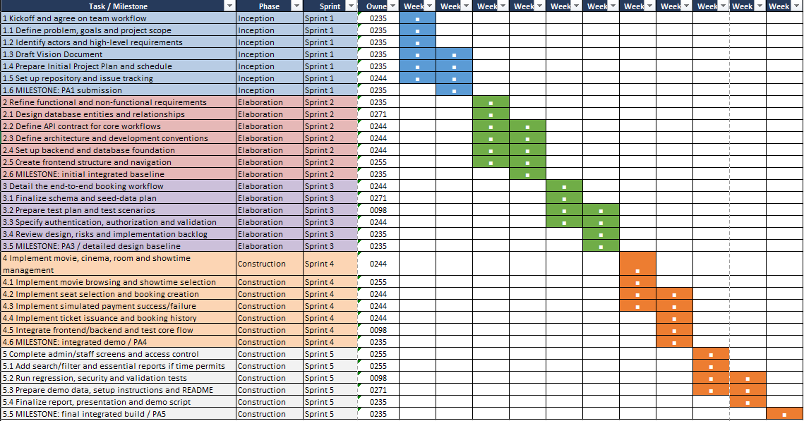

Iteration Objectives
Each Sprint will have specific objectives and expected outcomes. The objectives will be reviewed at the beginning and end of each Sprint, and detailed tasks will be maintained in JIRA.
Iteration | Period | Objectives
Sprint 1 | October 3–17, 2026 | Establish the project scope and initial requirements; prepare the Vision document and initial project plan; identify core use cases; configure the repository and collaboration tools.
Sprint 2 | October 17–30, 2026 | Refine requirements; identify entities and relationships; develop the initial database design; define the system architecture and API contracts; establish the development environment and initial backend foundation.
Sprint 3 | October 31–November 13, 2026 | Complete the detailed database and API design; verify initial database mappings and backend components; prepare the frontend structure; establish validation and error-handling conventions; prepare the testing plan.
Sprint 4 | November 14–27, 2026 | Implement and integrate the main movie, showtime, seat selection, booking, simulated payment, and ticket functions; develop essential administrative interfaces; test the integrated booking workflow.
Sprint 5 | November 28–December 12, 2026 | Complete remaining core functions; conduct integration, regression, and acceptance testing; fix critical defects; prepare the final demonstration environment, documentation, and project deliverables.
These objectives are initial targets rather than guarantees that every feature will be completed within the specified iteration. Task priorities may be adjusted according to dependencies, implementation progress, and feedback from the TAs.

Releases
The team plans to produce six software builds during the project. These builds represent development and testing checkpoints rather than six independent production releases. The first builds will focus on technical foundations, while later builds will progressively integrate the core business functions.
Build | Target Date | Description | Intended Use
Build 1 | October 17, 2026 | Initial project baseline, including the repository, development environment, initial requirements, and preliminary design artifacts. | Verify project setup and readiness for detailed development.
Build 2 | October 23, 2026 | Initial database and backend foundation, including database connectivity and preliminary entity mappings. | Verify database connectivity and basic backend operation.
Build 3 | October 30, 2026 | Initial backend APIs and selected frontend–backend communication. | Test basic API behavior, data validation, and component communication.
Build 4 | November 13, 2026 | Detailed design baseline and verified preliminary components for the main business functions. | Validate the design and technical readiness for broader implementation and integration.
Build 5 | November 27, 2026 | Integrated functional version containing the main booking workflow and essential administrative functions to the extent implemented. | Conduct functional and integration testing and identify remaining defects.
Build 6 | December 12, 2026 | Final integrated version with completed core functions, resolved critical defects, and prepared documentation. | Perform final verification and demonstrate the system.
The planned dates and contents may be revised as development progresses. Each build will be evaluated through relevant tests, documented defects, and a review of implemented functionality. The final build is intended for academic demonstration and evaluation; production readiness is not assumed.
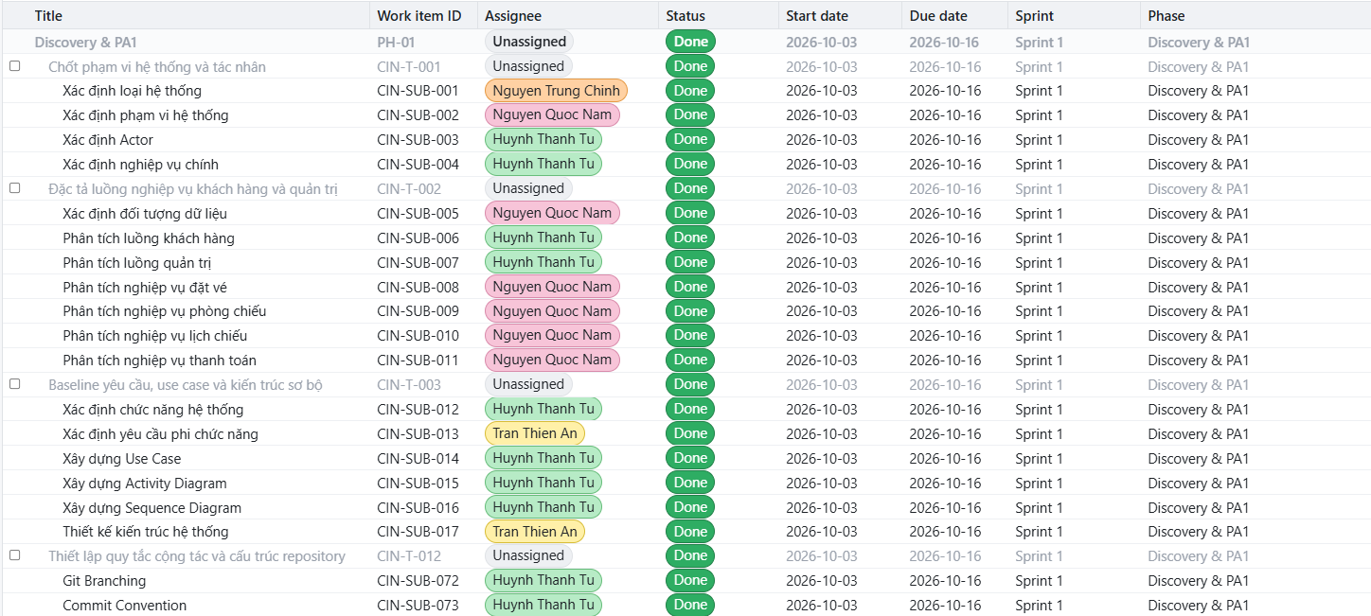
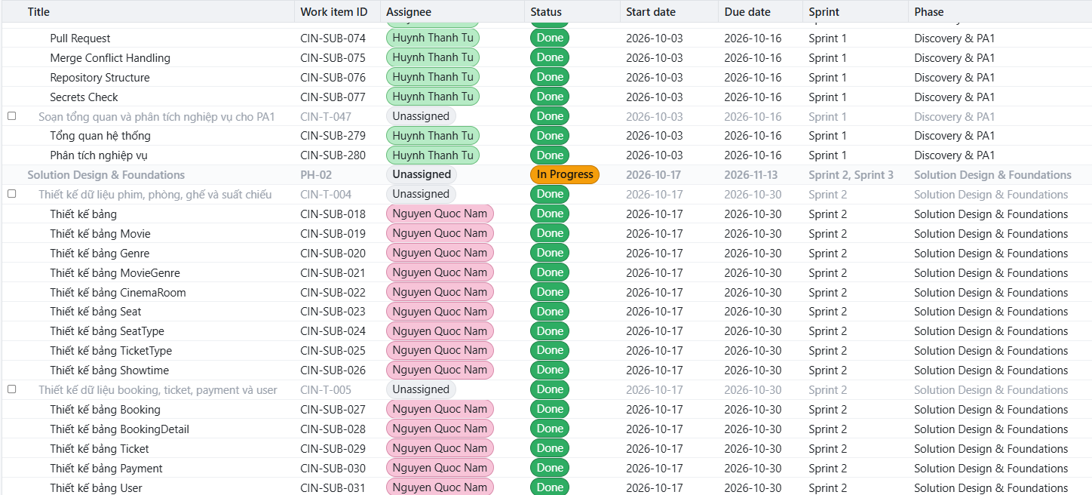
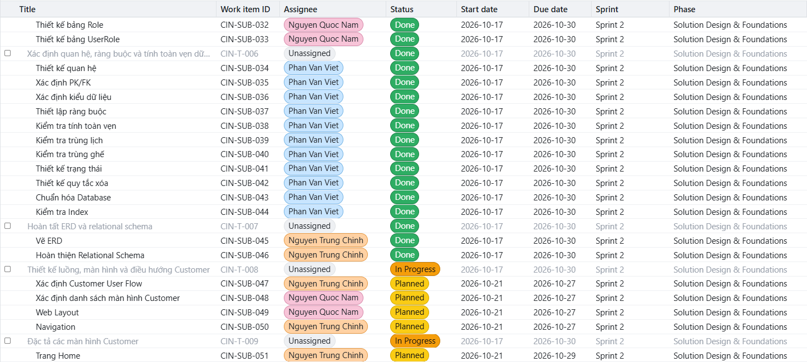
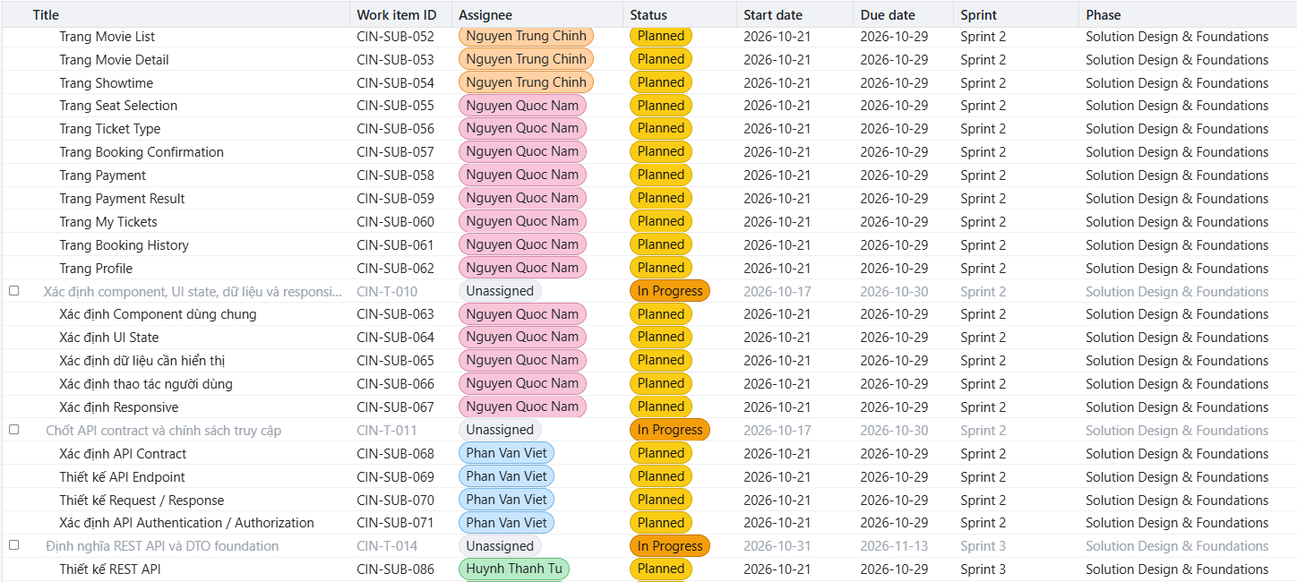
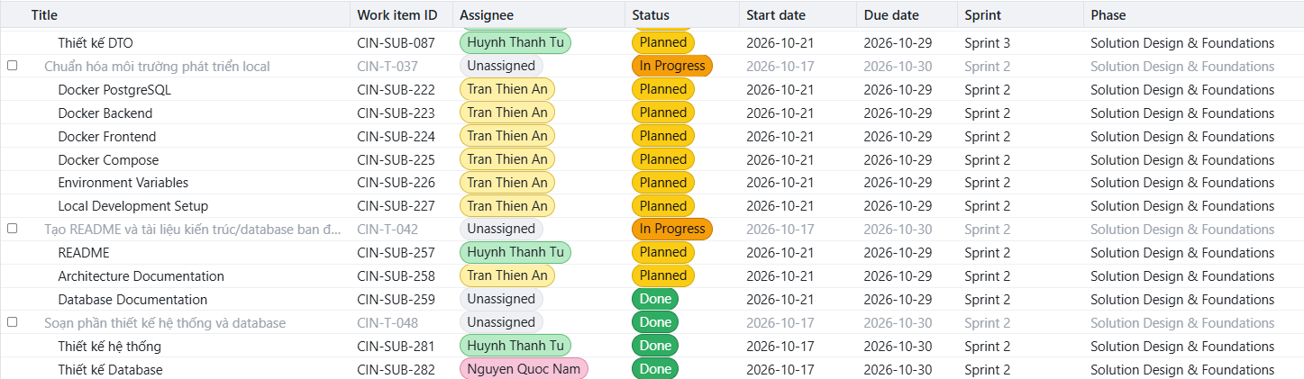

Project Schedule
The overall project schedule follows the five-Sprint structure specified in PA0. MS Project will be used to represent the project phases, Sprint periods, major activities, milestones, task dependencies, and resource assignments. JIRA will be used to manage the detailed tasks within each Sprint.
Phase / Sprint | Start Date | End Date | Major Milestones
Inception - Sprint 1 | October 3, 2026 | October 17, 2026 | Initial project plan, Vision document, weekly reports, and project setup completed.
Elaboration - Sprint 2 | October 17, 2026 | October 30, 2026 | Initial requirements, architecture, database design, and API specifications prepared.
Elaboration - Sprint 3 | October 31, 2026 | November 13, 2026 | Detailed design and testing plan prepared; preliminary technical components verified.
Construction - Sprint 4 | November 14, 2026 | November 27, 2026 | Core booking workflow and essential administrative functions integrated for testing.
Construction - Sprint 5 | November 28, 2026 | December 12, 2026 | Final build, regression testing, documentation, and project demonstration completed.
The six planned build checkpoints are described in Section 1.1.3. Major activities will be scheduled according to their dependencies. For example, the database schema and API contracts should be sufficiently stable before the corresponding frontend and backend components are integrated.
At the beginning of each Sprint, the team will review the remaining work and assign tasks according to priority and availability. At the end of each Sprint, the team will review completed work, test the current build, record unresolved defects, and update the subsequent Sprint plan where necessary.
The schedule is an initial baseline and may be adjusted to reflect actual progress. However, the overall plan will retain the five required Sprints and the corresponding course milestones unless the instructor provides different guidance.

Project Resourcing
The project will be carried out by a team of five student members. Each member will have a primary responsibility based on their technical skills and agreed specialization. Team members may collaborate across responsibilities when integration, testing, or workload balancing requires additional support.
Team Roles and Responsibilities
Role | Main Responsibilities | Required Skills
Project coordination and requirements | Maintain the project scope, requirements, schedule, documentation, and progress reports. Coordinate task assignments and communication. | Requirements analysis, planning, communication, and documentation.
Database design and development | Design and maintain the relational model, database schema, constraints, and database integration. | Relational database design, SQL, and data modeling.
Backend development | Implement APIs, business rules, authentication, authorization, booking operations, simulated payment, and ticket issuance. | C#, ASP.NET Core, API design, and database access.
Frontend development | Implement customer-facing and administrative interfaces and integrate them with backend APIs. | Web development, UI implementation, API integration, and client-side validation.
Testing and integration | Prepare test cases, verify component and end-to-end behavior, track defects, and coordinate integration checks. | Test design, debugging, API testing, and integration testing.
These roles represent the proposed primary responsibility areas. The final assignment of individual members to roles will be confirmed according to their actual skills, availability, and agreement within the team. The role distribution may be adjusted if workload or technical dependencies require it.
Staffing and Resource Acquisition
The project team has already been formed, so no external staff recruitment is planned. The five members will share responsibility for delivering the agreed project scope. If additional expertise is required, the team will first consult course materials, documentation, and the TAs rather than assume that additional personnel will be available.
Training and Skill Development
Team members will review the tools, frameworks, and development practices required for their assigned responsibilities. The planned learning activities include:
- Reviewing Git workflows, branching, merging, and code-review practices before substantial collaborative implementation.
- Reviewing the selected database technology, relational modeling, and database access framework before implementing data-dependent features.
- Reviewing backend API conventions, request validation, error handling, and authentication before implementing business functions.
- Reviewing frontend–backend integration and API testing before integrating customer and administrative interfaces.
- Reviewing test-case design, integration testing, and regression testing before the main testing activities in Construction.
Training will be conducted throughout the relevant Sprints rather than as a separate formal training phase. The team will aim to complete the necessary preparation before each member begins work on the corresponding technical tasks. Learning progress and any resulting schedule risks will be discussed during Sprint reviews.
The allocation of personnel and time will prioritize the core booking workflow, essential administrative functions, integration, and testing. Optional features, including AI-based recommendations, advanced analytics, and real payment gateway integration, will only be considered when sufficient time and resources remain.

Project Monitoring and Control
Project monitoring and control ensures that the Movie Theater Management and Online Ticket Booking System is developed according to the agreed requirements, project schedule, quality standards, and available resources. The team will monitor progress throughout the project lifecycle, identify deviations from the plan, manage risks, and control changes to project requirements and deliverables.
The project team will use Jira to manage tasks, assign responsibilities, and track progress, while GitHub will be used to manage source code, version history, and code changes. Project documents, including the Vision Document, requirements specifications, design documents, test plans, and final report, will be maintained and updated throughout the project.

Requirements Management
The requirements for the Movie Theater Management and Online Ticket Booking System are documented in the Vision Document and supporting requirements specifications. These documents define the project scope, actors, functional requirements, non-functional requirements, and business rules.
Any proposed change to the requirements must be recorded as a change request in Jira. The request should describe the proposed change, its rationale, its priority, and its potential impact on the project scope, schedule, implementation effort, database design, API contracts, and testing activities.
The Tech Lead and relevant team members will review each request to determine its feasibility and impact. Changes that affect the agreed project scope or major design decisions must be discussed and approved by the team before implementation. Approved changes will be reflected in the relevant project documents and Jira backlog. Rejected or deferred requests will remain documented with their decisions and reasons.
The team will prioritize requirements based on their importance to the core booking workflow, technical dependencies, and available development time. The essential workflow includes browsing movies and showtimes, selecting seats, creating bookings, processing simulated payments, and issuing tickets only after successful payment. Additional features will be considered according to the agreed scope and remaining capacity.

Reporting and Measurement
Updated cost and schedule estimates, and metrics summary reports, will be generated at the end of each iteration.
The Minimal Set of Metrics, as described in the RUP Guidelines: Metrics, will be gathered on a weekly basis. These include:
Earned value for completed tasks. This is used to re-estimate the schedule and budget for the remainder of the project, and/or to identify need for scope changes.
Total defects open and closed – shown as a trend graph. This is used to help estimate the effort remaining to correct defects.
Acceptance test cases passing – shown as a trend graph. This is used to demonstrate progress to stakeholders.
In addition, overall costs will be monitored against the project budget.

Risk Management
Risks will be identified in Inception Phase using the steps identified in the RUP for Small Projects activity “Identify and Assess Risks”. Project risk is evaluated at least once per iteration and documented in this table. The risks of the greatest magnitude are listed first in the table.
Risk Ranking (High, Medium, Low) | Risk Description and Impact | Mitigation Strategy and/or Contingency Plan
High | Schedule delays: The team may underestimate the effort required to implement, integrate, and test the system within the academic project schedule. This may result in incomplete features or late submission. | Break down major tasks into smaller, estimable tasks in Jira. Assign a primary owner and supporting members to each task. Review progress during each iteration and prioritize the core booking workflow if delays occur. Defer non-essential features when necessary.
High | Frontend and backend integration issues: Inconsistent API contracts, data formats, or error-handling behavior may cause integration failures and delay system testing. | Agree on API contracts and DTO formats before implementing dependent features. Integrate components incrementally, review API changes with affected members, and test each integrated workflow early. If integration problems persist, prioritize the core end-to-end booking flow.
High | Incorrect seat booking or double booking: Concurrent requests may allow multiple customers to book the same seat for the same showtime, resulting in inconsistent booking data and a poor user experience. | Enforce seat availability and booking rules on the backend. Use appropriate database constraints and transaction or concurrency controls. Test duplicate and concurrent booking scenarios. If a defect is discovered, disable the affected booking operation until the issue is corrected.
High | Payment and ticket consistency errors: A failed or incomplete simulated payment may incorrectly result in a confirmed booking or valid ticket. | Define explicit booking and payment states, validate payment outcomes on the server, and issue tickets only after successful payment. Test successful, failed, and repeated payment requests. If an inconsistency occurs, prevent ticket issuance and correct the affected booking state.
Medium | Unclear or changing requirements: Incomplete requirements or uncontrolled scope changes may cause rework in the database, API, frontend, and test cases. | Maintain the Vision Document and supporting requirements documents. Record proposed changes in Jira, evaluate their impact on scope and schedule, and obtain team approval before implementation. Defer changes that are not essential to the agreed scope.
Medium | Database design or migration problems: Changes to entities, relationships, constraints, or migrations may break existing functionality or cause data inconsistencies. | Review the database design before implementation, coordinate schema changes among relevant members, and test migrations against a development database. Keep migration files and database scripts under version control. Back up important data before risky schema changes.
Medium | Insufficient testing and regression defects: Limited time or incomplete test coverage may allow functional, validation, or authorization defects to remain in the final submission. | Prepare test scenarios for core workflows and important failure cases. Test incrementally during each iteration and run regression tests after significant changes. Reserve time before submission for fixing high-severity defects.
Medium | Uneven workload or member unavailability: Differences in workload, unexpected absences, or tasks depending on a single member may block progress. | Track assignments and task status in Jira. Assign supporting members to critical tasks, document implementation decisions, and share technical knowledge. Redistribute work when a member becomes unavailable or a task falls behind schedule.
Low | Loss of source code or project documentation: Local device problems or accidental file changes may result in lost work. | Push committed work to the shared GitHub repository regularly. Keep important documents and other artifacts backed up. Recover lost committed code from the remote repository and use Git history to restore or revert incorrect changes.

Configuration Management
Appropriate tools will be selected which provide a database of Change Requests and a controlled versioned repository of project artifacts.
All source code, test scripts, and data files are included in baselines. Documentation related to the source code is also included in the baseline, such as design documentation. All customer deliverable artifacts are included in the final baseline of the iteration, including executables.

